**VR-201-202-XX Healy Quarterly Inspection**

|  |  |  |
| --- | --- | --- |
| SOURCE INFORMATION and Inspection Date: _____________________________________________ | | |
| Facility (DBA): ____________________________ | | Individual conducting inspection: _________ |
| Facility Street Address: _____________________ | | Affiliation: ___________________________ |
| City/Zip: _________________________________ | | P/O Number: __________________________ |
| **Valve** | **Clean Air Separator Inspection**  Check One Box Below | |
| A | Open Closed | |
| B | Open Closed | |
| C | Open Closed | |
| D | Open Closed | |
| **Plug** |  | |
| E | Installed Missing | |
| F | Installed Missing | |

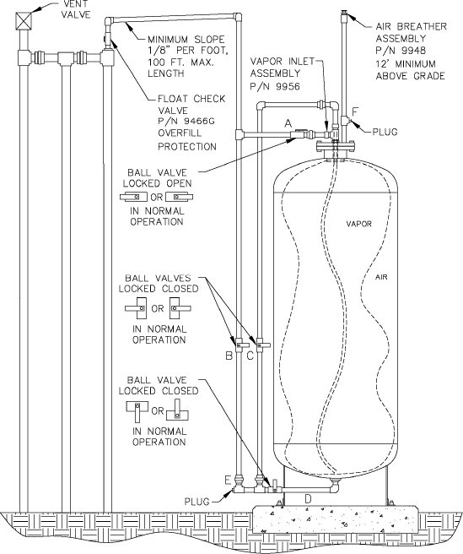**Clean Air Separator Normal Operating Configuration**

**Verify that the Healy nozzle will not dispense fuel when the dispenser is authorized (ready to dispense fuel) and the boot is in a free state (uncompressed).** To conduct this inspection, remove the nozzle from the dispenser, authorize the dispenser, and point the nozzle into an approved container (do not compress the mini-boot in any manner) and actuate the nozzle lever. No fuel should dispense. Any nozzle that dispenses fuel with the miniboot in a free state condition, as determined by this inspection procedure, shall be removed from service until repaired or replaced.

|  |  |  |  |  |
| --- | --- | --- | --- | --- |
| **Nozzle #** | **Pass/Fail** |  | **Nozzle #** | **Pass/Fail** |
| _________ | _________ | _________ | _________ |
| _________ | _________ | _________ | _________ |
| _________ | _________ | _________ | _________ |
| _________ | _________ | _________ | _________ |
| _________ | _________ | _________ | _________ |
| _________ | _________ | _________ | _________ |
| _________ | _________ | _________ | _________ |
| _________ | _________ | _________ | _________ |
| _________ | _________ | _________ | _________ |
| _________ | _________ | _________ | _________ |
| _________ | _________ | _________ | _________ |
| _________ | _________ | _________ | _________ |
| _________ | _________ | _________ | _________ |
| _________ | _________ | _________ | _________ |
| _________ | _________ | _________ | _________ |
| _________ | _________ | _________ | _________ |
| _________ | _________ | _________ | _________ |

**VP 1000 Vacuum Pump Inspection**

Do the VP1000 vacuum pumps have loose or damaged vapor line connections? **YES NO**

(If copper tubing is kinked or loose remove the dispenser from service and call a Healy certified Technician for service)