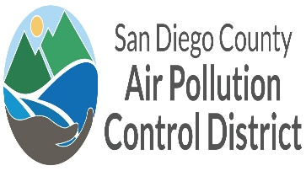
SAN DIEGO AIR POLLUTION CONTROL DISTRICT  COMPLIANCE DIVISION 10124 OLD GROVE ROAD SAN DIEGO CA 92131  PHONE (858) 586-2650 FAX (858) 586-2651 | APCD USE ONLY
 | SECTOR
 | ID#
 | NOV#

DETERMINATION OF VST ECS MEMBRANE PROCESSOR ACTIVATION PRESSURE

Exhibit 9 of ARB E.O. VR 203-X or VR-204-X

Facility Name: A/C or PO Number: Time of Test:
(Record exact time of test in order to demonstrate proper test sequencing as required in Attachment L)

FACILITY AND TESTING EQUIPMENT INFORMATION
Date and Time of Last Fuel Delivery:
Date and Time of Last TP-201.3/TP-96-1 Performed:
Calibration Date of Digital Manometer:
Processor Status During Test: | ☐ ON ☐ OFF
Leak Check Successfully Completed on Test Assembly? | ☐ YES ☐ NO

TEST RESULTS
Pressure (Inches W.C.) | Processor Activated
0.10 | ☐ Yes | ☐ No
0.20 | ☐ Yes | ☐ No
0.30 | ☐ Yes | ☐ No
0.40 | ☐ Yes | ☐ No
0.50 | ☐ Yes | ☐ No
Pass (P) or Fail (F)

03/21 Page 1 of 1

