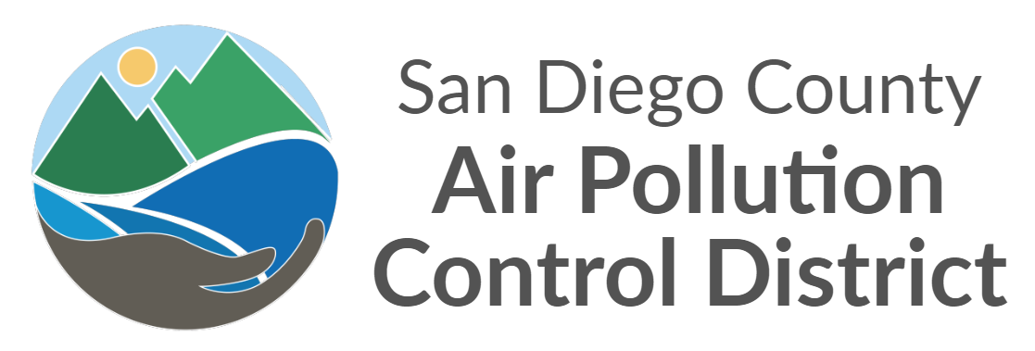

International Border Community Air Monitoring Plan – Fact Sheet
  - February 2022

International Border Community
The International Border Community was selected for the Community Air Protection Program by the California Air Resources Board (CARB) in February 2022. This program requires the development of a Community Air Monitoring Plan (CAMP) and a Community Emissions Reduction Program (CERP). To co-develop these programs and facilitate communication between air quality professionals and community residents, the International Border Community Steering Committee was formed, comprised of individuals who live, work, or own a business within the community boundaries, and partner organizations who have an interest and role in improving air quality in the community. The community experiences air pollution from numerous sources, including heavy traffic near the ports of entry in San Ysidro and Otay Mesa, dust from offroad vehicles used by Border Patrol agents, freight trains and rail yards, industry, warehouses and associated heavy-duty truck traffic, construction, untreated wastewater in the Tijuana River, and two airports: Brown Field Municipal Airport and Tijuana International Airport. Data from various government agencies shows elevated rates of asthma and cardiovascular disease among International Border Community residents, who also report frequent headaches and nausea.

Air Pollution Monitoring
The CAMP incorporated community feedback, health information, and existing air monitoring data. Based on this information, the San Diego County Air Pollution Control District (APCD) has decided to monitor for the following types of air pollution:
- Particulate matter
- Diesel particulate matter
- Volatile organic compounds
- Airborne metals
- Odor-causing chemicals
In addition to these monitoring priorities, the APCD will gather meteorological data to analyze the effects that weather and climate can have on air pollution levels and community exposure. Air monitoring instruments will include continuous sensors, which provide near-real-time data, and instruments that collect samples over a 24-hour period. 24-hour samples will be sent to third-party contract laboratories for analysis. Routine maintenance, including calibrations, flow and leak checks, audits, and more will be performed on all equipment to ensure data quality and instrument performance.
Monitoring is already conducted at two sites within the International Border Community: at monitoring sites at Donovan State Prison and San Ysidro Fire Station #29. Additional monitoring sites will be constructed based on community feedback, location suitability, and available resources, including equipment and staff. A monitoring site at the California Highway Patrol Commercial Vehicle Enforcement Facility at the Otay Mesa port of entry is currently in development. Additional locations of interest include the San Ysidro port of entry, the Tijuana River Valley, Brown Field Municipal Airport, schools, parks, senior centers, along California State Route 905, and near warehouses and other areas affected by heavy-duty truck traffic. Additional monitoring is conducted on the Mexican side of the border at the United States Consulate General near the Tijuana International Airport, and various particulate matter sensors are deployed in Tijuana by the State of Baja California. More information on these particulate matter sensors can be found on the Purple Air website <purpleair.com>.

Figure 1 Potential and current monitoring sites and pollution targets for each in the International Border Community

Roles and Responsibilities
Community air monitoring and the Community Air Protection Program more broadly rely on multiple agencies and groups to coordinate with one another. APCD and CARB perform the bulk of air sampling and data analysis, with CARB providing technical and monitoring support to APCD. The International Border Community Steering Committee serves as a liaison between the residents of the community and the government agencies. Casa Familiar, a community-based organization in the International Border Community, and the San Diego State University School of Public Health regularly contribute to Steering Committee meeting discussions and perform some air monitoring and sampling as well. Finally, CARB and APCD meet regularly with representatives of Mexican government agencies to assess the monitoring network on each side of the border and share the latest efforts and results with one another.

Air Quality Data Processing
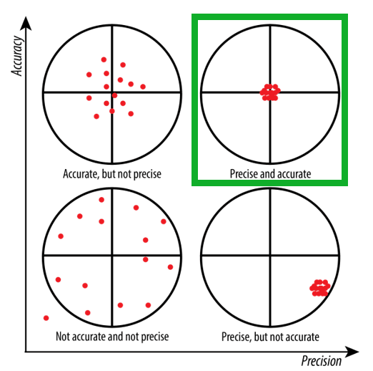
All air quality data is processed to ensure that it passes various quality assurance and control metrics. Data must be accurate, precise, complete, and without bias. Data is accurate when a measured value matches the true, actual value. Precision means that a sample run multiple times gives the same results with repetition. Completeness refers to the amount of data that meets quality requirements as a fraction of the entire pool of data. Data is biased when different results are obtained by different personnel or equipment, which should not happen. Routine maintenance helps prevent data bias while ensuring accuracy, precision, and completeness.
APCD chemists perform thorough review on all data, including continuous sampler data and analysis reports from third-party laboratories. Besides verifying quality, chemists also examine the trends in pollution levels over time, the effects that the weather and time of day have, how different areas of the community are affected differently, and more.
Figure 2 Visual representation of precision, accuracy, and how they are different. Precision answers whether analyzing the same sample multiple times produce the same results, while accuracy measures how close a measurement is to the actual, “true” value. In the top right, the ideal scenario is shown surrounded by a green box: simultaneously high precision and accuracy

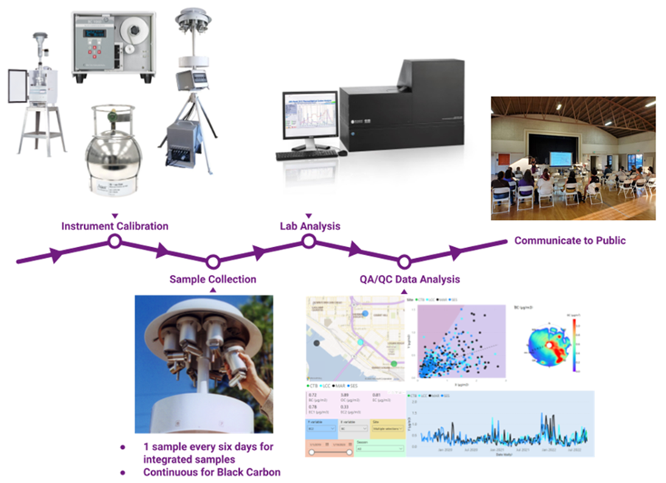
Figure 3 Data analysis workflow followed by APCD chemists

Community Engagement
The International Border Community, its Steering Committee, and community members are crucial to the success of this program. Ongoing communication will be essential to maintaining the program, both to evaluate past and present efforts and to identify future actions to improve air quality. APCD and CARB will make air pollution data available to the community in a variety of ways, including through presentations, subcommittee meetings, progress reports, and making data available online. Air pollution data will help identify steps that community residents can take in their day-to-day lives to reduce their exposure to harmful air pollutants. This data will also help assess the effectiveness of the Community Emissions Reduction Program (CERP), which is a document currently under development that will identify strategies to reduce air pollution in the community.

