

International Border Community Air Monitoring Plan – Supplemental Document

February 2023

# Table of Contents

Table of Contents 1

List of Figures 2

List of Tables 3

Appendix A: Standard Operating Procedures, Instrument Manuals, and Analysis Methods 1

Appendix B: AQS Data Flags 3

Appendix C: Target Compounds 6

Appendix D: EPA Sampling Schedule 8

Appendix E: Websites 9

San Diego County Air Pollution Control District 9

California Air Resources Board – AQview 10

United States Environmental Protection Agency Air Quality System 11

# List of Figures

Figure 1 2023 EPA Sampling Schedule. 12

Figure 2 San Diego County Air Pollution Control District website homepage.. 13

Figure 3 San Diego Air Pollution Control District Air Quality page.. 13

Figure 4 San Diego County Air Pollution Control District Air Quality Forecast page 14

Figure 5 California Air Resources Board AQview homepage 14

Figure 6 California Air Resources Board AQview Continuous Monitoring data page 15

Figure 7 California Air Resources Board AQview Additional Monitoring & Reports 15

Figure 8 United States Environmental Protection Agency Air Quality System homepage 16

# List of Tables

Table 1 Documents referenced by chemists, technicians, and third-party laboratories for conducting community air monitoring 1

Table 2 Null codes for data uploaded to AQS. 3

Table 3 Qualifier codes for data uploaded to AQS 3

Table 4 List of target VOCs 6

Table 5 List of target metals 7

# Appendix A: Standard Operating Procedures, Instrument Manuals, and Analysis Methods

Table 1 lists and describes the documents that guide the Community Air Monitoring Plan. All documents are available to read and review upon request.

Table Documents referenced by chemists, technicians, and third-party laboratories for conducting community air monitoring

|  |  |  |
| --- | --- | --- |
| **Document** | **Project** | **Description** |
| Organic and Elemental Carbon Program: Data Analysis & AQS Formatting (Python) Guide | EC | Guide for the automated analysis of elemental carbon data reports from third-party laboratory, Desert Research Institute |
| Desert Research Institute SOP – Model 2001 Thermal/Optical Carbon Analysis of Aerosol Filter Samples – Method IMPROVE_A | EC | Procedure followed by third-party laboratory, Desert Research Institute, to analyze elemental carbon filters sent by APCD |
| Field Operation Manual – Model SASS & SuperSASS PM2.5 Ambient Chemical Speciation Samplers | EC | Manual for using the Met One Super Speciation Air Sampling System for elemental carbon sampling |
| SOP for the Met One SASS | EC | Guide for flow checks, calibrations, and audits of the Met One Super Speciation Air Sampling System |
| Operation Manual – BC 1060 Black Carbon Monitor | BC | Manual for using the Met One BC 1060 for black carbon monitoring |
| SOP – Calibration and Audit of the Met One BC 1060 Black Carbon Monitor | BC | Guide for flow checks, calibrations, and audits of the Met One BC 1060 |
| SOP – Black Carbon Data Validation and Transmittal of AQS Data | BC | Guide for the preparation of continuous black carbon data into AQS format |
| Operation Manual – Met One E-SEQ-FRM Sequential Reference Method Particulate Sampler | Metals | Manual for using the Met One E-Sequential Federal Reference Method instrument for metals sampling |
| SOP – Calibration and Audit of the Met One E-Sequential FRM Instrument | Metals | Guide for flow checks, calibrations, and audits of the Met One E-Sequential Federal Reference Method instrument |
| Compendium Method IO-3.5 – Determination of Metals in Ambient Particulate Matter Using Inductively Coupled Plasma/Mass Spectrometry (ICP/MS) | Metals | Method prepared by the EPA for digesting and analyzing metals collected on filters using ICP/MS |
| SOP – Analysis of Volatile Organic Compounds for the Toxics VOC Program | VOCs | Historical procedures used by APCD in the internal Toxics – VOCs program for sampling, analyzing, and preparing data for AQS upload |
| SOPs – Collection of SGS Galson Standard Operating Procedures for VOC Analysis | VOCs | Collection of all SOPs used by third-party laboratory, SGS Galson, in the analysis of VOCs in canister samples |
| Method TO-15A – Determination of Volatile Organic Compounds (VOCs) in Air Collected in Specially Prepared Canisters and Analyzed by Gas Chromatography–Mass Spectrometry (GC-MS) | VOCs | Method prepared by the EPA for collecting and analyzing VOC samples in canisters |
| National Air Toxics Trends Stations Technical Assistance Document (NATTS TAD) | Metals & VOCs | Guidance document for air monitoring agencies performing air toxics sampling and analysis |

# Appendix B: Quality Assurance and Control Criteria

This section details the criteria that must be met to ensure high-quality data as well as the corrective action to be taken for specific failures.

## Volatile Organic Compounds

Table 2 is from the NATTS TAD that summarizes sampling and laboratory QA/QC criteria for VOC monitoring. Table 3 summarizes the corrective action for specific failures related to VOC analysis.

Table 2 VOC QA/QC criteria from NATTS TAD

|  |  |  |  |
| --- | --- | --- | --- |
| **Parameter** | **Description and Details** | **Required Frequency** | **Acceptance Criteria** |
| Instrument Blank (IB) | Analysis of swept carrier gas through the preconcentrator to demonstrate the  instrument is sufficiently clean to begin analysis | Prior to ICAL and daily beginning CCV | Each target VOC’s concentration < 3x MDL or 0.2 ppb, whichever is lower |
| BFB Tune Check | 50 ng injection of BFB for tune verification of quadrupole MS detector | Prior to initial calibration and every 24 hours of analysis thereafter | Abundance criteria listed in Table 4.2-2 (from TAD) |
| Initial Calibration (ICAL) | Analysis of a minimum of five calibration levels covering approximately  0.1 to 5 ppb | Initially, following failed BFB tune check, failed CCV, or when changes/maintenance to the instrument affect  calibration response | Average RRF ≤ 30% RSD and each calibration level must be within ± 30% of nominal  For quadratic or linear curves, r ≥ 0.995, each calibration level must be within ± 30%  of nominal |
| Secondary Source Calibration  Verification (SSCV) | Analysis of a secondary source standard at the mid-range of the  calibration curve to verify ICAL accuracy | Immediately after each ICAL | Recovery within ± 30% of nominal or RRF within ±30% of the mean ICAL RRF |
| Continuing Calibration Verification (CCV) | Analysis of a known standard at the mid-range of the calibration curve to verify ongoing instrument calibration | Following each daily BFB tune check and every 24 hours of analysis; recommended after each  ten sample injections and to conclude each sequence | Recovery within ± 30% of nominal or RRF within ±30% of the mean ICAL RRF |
| Canister Cleaning Batch Blank | A canister selected for analysis from a given batch of clean canisters to ensure acceptable background levels in the batch of cleaned canisters | One canister from each batch of cleaned canisters – Canister chosen must represent no more than 10  total canisters. | Each target VOC’s concentration < 3x MDL or 0.2 ppb, whichever is lower (All Tier I Core analytes must meet this criterion) |
|  |  |  |  |
| Internal Standards (IS) | Deuterated or not naturally occurring compounds co-analyzed with samples to monitor  instrument response and assess matrix effects | Added to all calibration standards, QC samples, and field-collected samples | Area response for each IS compound within  ± 40% of the average response of the ICAL |
| Preconcentrator Leak Check | Pressurizing or evacuating the canister connection to verify as leak-free | Each standard and sample canister connected to the instrument | < 0.2 psi change/minute or manufacturer recommendations |
| Method Blank (MB) | Canister filled with clean diluent gas | One with every analysis batch of 20 or fewer field- collected samples | Each target VOC’s concentration < 3x MDL or 0.2 ppb, whichever is lower |
| Laboratory Control Sample (LCS) | Canister spiked with known amount of target analyte at approximately the lower third of the  calibration curve | (Recommended) One with every analysis batch of 20 or fewer field-collected samples | Each target VOC’s recovery must be 70 to 130% of its nominal spiked amount |
| Duplicate Sample | Field sample collected through the same inlet probe as the primary sample | 10% of primary samples for sites performing duplicate sample collection (as prescribed  in workplan) | Precision ≤ 25% RPD of primary sample for concentrations ≥ 5x MDL |
| Collocated Sample | Field sample collected through a separate inlet probe from the primary sample | 10% of primary samples for sites performing collocated sample collection (as prescribed in workplan) | Precision ≤ 25% RPD of primary sample for concentrations ≥ 5x MDL |
| Replicate Analysis | Replicate analysis of a field-collected sample  (chosen by analyst) | Once with every analysis sequence (as prescribed in  workplan) | Precision ≤ 25% RPD for target VOCs with concentrations ≥ 5x MDL |
| Retention Time (RT) | RT of each target compound and internal standard | All qualitatively identified compounds and internal standards | Target VOCs within ± 0.06 RRT units of mean ICAL RRT  IS compounds within ± 0.33 minutes of the mean ICAL RT |
| Canister Cleaning Batch Blank | Minimally one canister selected for analysis from a given batch of clean canisters to ensure acceptable background levels in the batch of cleaned canisters - must represent no more than 10  canisters | n/a | Each target VOC’s concentration < 3x MDL or 0.2 ppb, whichever is lower |
| Canister Starting Pressure Determination | Each canister prior to collection of a field sample or preparation of a  calibration standard or laboratory QC sample | n/a | Vacuum > 28" Hg as determined with calibrated pressure gauge or transducer |
| Compound Identification | Qualitative identification of each target VOC in each standard, blank, QC sample, and field- collected sample (including field QC  samples) | n/a | Signal-to-noise ≥ 3:1  RT within prescribed window  Ion abundances of at least one qualifier ion within 30% of ICAL mean  Peak apexes co-maximized (within one scan  for quadrupole MS) for quantitation and qualifier ions |
|  |  |  |  |
| Method Detection Limit | Determined initially and minimally annually thereafter and when method changes alter instrument sensitivity | n/a | MDL determined via 4.1 must be: Acrolein  ≤ 0.09 μg/m3 Benzene ≤ 0.13 μg/m3 1,3- Butadiene ≤ 0.10 μg/m3 Carbon Tetrachloride ≤ 0.017 μg/m3 Chloroform ≤  0.50 μg/m3 Tetrachloroethylene ≤ 0.17 μg/m3 Trichloroethylene ≤ 0.20 μg/m3 Vinyl Chloride ≤ 0.11 μg/m3 These MDL MQOs current as of October 2015. Refer to  current workplan template for up to date MQOs. |
| Stock Standard Gases | Purchased stock standard gases for each target VOC All standards | n/a | Certified and accompanied by certificate of analysis Recertified or replaced annually unless a longer expiration is specified by the supplier |
| Proficiency Testing | Blind sample submitted to each laboratory to evaluate laboratory bias Two per calendar year | n/a | Each target compound within ± 25% of the assigned target value  Failure of one PT must prompt corrective action. Failure of two consecutive PTs (for a specific core analyte) must prompt qualification of the analyte in field collected  samples until return to conformance. |
| Canister Leak Test | Testing of the leak tightness of each canister in the agency fleet Annually, may be performed simultaneously with canister zero air  check | n/a | Leak rate must be ≤ 0.1 psi/day |
| Canister Zero Check | Verification that a canister does not contribute to positive bias over an approximate 30-day period  Strongly Recommended: Each canister in the agency fleet once annually (or as defined by agency policy) or after major maintenance such as  replacement of valve | n/a | All Tier I core target compounds must be <  0.2 ppb or < 3x MDL, whichever is lower |
| Canister Known Standard Gas Check | Verification that a canister does not contribute to bias over an approximate 30- day period  Strongly Recommended: Each canister in the agency fleet once annually (or as defined by agency policy) or after major maintenance such as  replacement of valve | n/a | All Tier I core target compounds must be within ± 30% of nominal |

Table 3 Corrective action for specific QA/QC failures for VOC monitoring

|  |  |
| --- | --- |
| **QA/QC Measure** | **Fail Action** |
| MS Tuning | Retune MS, recalibrate, and reanalyze samples. |
| System Monitoring Compound (SMC) | Retune MS, recalibrate, and reanalyze samples. |
| Non ISTD RT Difference | Flag samples, repair system, recalibrate. |
| ISTD RT Difference | Repair system, recalibrate, update RT. |
| Blank (system or canister) | System blank – repair system restart batch.  Canister blank – flag canisters or clean canisters. |
| LCS | Flag samples, recalibrate |
| CCV | Batch is invalid, recalibrate, and reanalyze samples. |
| SSCV | Flag samples, repair system, or recertify standards. |
| Laboratory Replicate | Batch is invalid, repair system, recalibrate, and reanalyze samples. |
| ISTD Abundance | Batch is invalid, recalibrate, and reanalyze samples. |
| Collocated Sample | Calculate CV quarterly; if CV > 15%, flag samples. |
| Completeness | Collect makeups before next run or within the same month. |
| Leak Check | Check connections, repair system, inform lead chemist |
| Canister run | Inform lead chemist |
| Canister under/overfilled | Inform lead chemist |

## Metals

Table 4 is from Compendium Method IO-3.5 and summarizes the laboratory QC criteria for airborne metals analysis. Table 5 is from the EPA Quality Assurance Guidance Document and summarizes the field sampler QC criteria for airborne metals sampling. Table 6 dictates the corrective action that will be taken based on specific QC failures.

Table 4 QA/QC criteria for metals analysis from EPA Compendium Method IO-3.5

|  |  |  |
| --- | --- | --- |
| **QC procedure** | **Typical frequency** | **Criteria** |
| Initial calibration (IC) | At the beginning of the analysis | R2 ≥ 0.995 |
| Initial calibration verification (ICV) | Immediately after initial calibration | 90%-110% of the actual concentration |
| Initial calibration blank (ICB) | Immediately after initial calibration verification | May be less than project detection limits (MDLs) |
| High standard verification (HSV) | Following the initial calibration blank analysis | 95%-105% of the actual concentration |
| Interference check standard (ICS) | Following the high standard verification, every 8 hours, and at the end of a run | 80%-120% of the actual concentration |
| Continuing calibration verification (CCV) | Analyzed before the first sample, after every 10 samples, and at the end of the run | 90%-110% of the actual concentration |
| Continuing clarification blanks (CCBs) | Analyzed following each continuing calibration verification | Must be less than project detection limits (MDLs) |
| Reagent blank (RB) or Method blank (MB) | 1 per 40 samples, a minimum of 1 per batch | Must be less than project detection limits (MDLs) |
| Laboratory control spike (LCS) or Laboratory fortified blanks (LFB) | 1 per 20 samples, a minimum of 1 per batch | 80%-120% recovery |
| Duplicate and/or spike duplicate | 1 per sample batch | RPD <20% |
| Matrix spike (MS) | 1 per 20 samples per sample batch | Percent recovery of 75%-125% |
| Serial dilution | 1 per sample batch | 90%-110% of undiluted sample |
| Sample dilution | Dilute sample beneath the upper calibration limit but no lower than at least 5X the MDL | As needed |

Table 5 QA/QC Criteria for metals field samplers from the EPA Quality Assurance Guidance Document

|  |  |  |
| --- | --- | --- |
| **QA/QC Criteria** | **Frequency** | **Acceptance Criterion** |
| ***Field Calibrations and Routine Checks*** | | |
| One-point flow rate check at design flow rate | Monthly | ±5% of transfer standard; and ±5% of design flow rate |
| External leak check(a) | Conducted with monthly flow check | ≤ 0.1 L/min |
| Internal leak check | If external leak check fails, refer to manufacturer operating manual | ≤ 0.1 L/min |
| One-point temperature check | Monthly | ±2 °C of standard |
| Pressure verification | Monthly | ±10 mmHg |
| Clock/timer verification | Monthly | 1 min/month |
| Other calibrations as specified by manufacturer | Per manufacturer’s SOP | per manufacturer’s SOP |
| ***Quarterly Checks and Audits*** | | |
| External leak check(a) | Semi-annual unless failed audit then at least quarterly until passes for 2 quarters | ≤ 0.1 L/min |
| Internal leak check | If external leak check fails, refer to manufacturer operating manual | ≤ 0.1 L/min |
| Temperature audit | Semi-annual unless failed audit then at least quarterly until passes for 2 quarters | ±2 °C |
| Pressure audit | Semi-annual unless failed audit then at least quarterly until passes for 2 quarters | ±10 mmHg |
| Flow rate audit | Semi-annual unless failed audit then at least quarterly until passes for 2 quarters | ±5% of audit standard  ±5% of design flow rate |
| ***Initial Installation Calibration and recalibrations thereafter*** | | |
| Temperature calibration | On installation, annually, or if verification/audit indicates drift or failure | ±2°C of standard |
| Pressure calibration | On installation, then annually, or if verification/audit indicates drift or failure | ±10 mmHg |
| Flow rate calibration | On installation, annual, or if verification/audit indicates drift or failure | ±2% of transfer standard at each flow rate |
| Design flow rate adjustment | As needed | ±2% of design flow rate |

Table 6 Corrective action for QA/QC failures in metals monitoring

|  |  |  |  |
| --- | --- | --- | --- |
| **QC procedure** | | **Failed Action** | |
| Initial calibration (IC) | | Batch is aborted, repair system, and recalibrate | |
| Initial calibration verification (ICV) | | Batch is aborted, repair system, and recalibrate | |
| Initial calibration blank (ICB) | | Samples < 5x Blank are flagged | |
| High standard verification (HSV) | | Batch is aborted, repair system, and recalibrate | |
| Interference check standard (ICS) | | Batch is invalid, repair system, recalibrate, and reanalyze samples | |
| Continuing calibration verification (CCV) | | Batch is invalid, repair system, recalibrate, and reanalyze samples | |
| Continuing clarification blanks (CCBs) | | Samples < 5x Blank are flagged | |
| Reagent blank (RB) or Method blank (MB) | | Batch is flagged | |
| Laboratory control spike (LCS) or Laboratory fortified blanks (LFB) | | Batch is qualified | |
| Duplicate and/or spike duplicate | | Batch is invalid, repair system, recalibrate, and reanalyze samples | |
| Matrix spike (MS) | | Batch is invalid, repair system, recalibrate, and reanalyze samples | |
| Serial dilution | | Batch is invalid, repair system, recalibrate, and reanalyze samples | |
| ***Field Calibrations and Routine Checks*** | | | |
| One-point flow rate check at design flow rate | | Correct problems. Recalibrate the sampler if needed. Applies to all flow channels | |
| External leak check(a) | | Determine cause of leak and correct. Validate and/or calibrate the sampler flow rate.  Applies to all flow channels | |
| Internal leak check | | Determine cause of leak and correct. Validate and/or calibrate the sampler flow rate.  Applies to all flow channels | |
| One-point temperature check | | Conduct a 3-point calibration to verify compliance. If failed 3-pt Cal, troubleshoot, and recalibrate | |
| Pressure verification | | Troubleshoot and recalibrate or replace sensor | |
| Clock/timer verification | | Adjust Clock/ timer | |
| Other calibrations as specified by manufacturer | | per manufacturer’s SOP | |
| ***Quarterly Checks and Audits*** | | | |
| External leak check(a) | | Determine cause of leak and correct. Validate and/or calibrate the sampler flow rate.  Applies to all flow channels | |
| Internal leak check | | Determine cause of leak and correct. Validate and/or calibrate the sampler flow rate.  Applies to all flow channels | |
| Temperature audit | | Conduct a 3-point calibration to verify compliance. If failed 3-pt Cal, troubleshoot, and recalibrate | |
| Pressure audit | | Troubleshoot and recalibrate or replace sensor | |
| Flow rate audit | | Correct problems. Recalibrate the sampler, if needed. Applies to all flow channels | |
| ***Initial Installation Calibration and recalibrations thereafter*** | | | |
| Temperature calibration | | Conduct a 3-point calibration to verify compliance. If failed 3-pt Cal, troubleshoot, and recalibrate | |
| Pressure calibration | | Troubleshoot and recalibrate or replace sensor | |
| Flow rate calibration | | Correct problems. Recalibrate the sampler if needed. Applies to all flow channels | |
| Design flow rate adjustment | | Correct problems. Recalibrate the sampler if needed. Applies to all flow channels | |

## Black Carbon and PM2.5

Table 7 is from the EPA Quality Assurance Guidance Document and summarizes the QA/QC actions to be performed routinely on the Met One BC 1060 and Teledyne T640X samplers. Table 8 details the corrective action for BC 1060 and T640X QA/QC failures.

Table 7 QA/QC criteria for Met One BC 1060 black carbon and Teledyne T640X particulate matter samplers from the EPA Quality Assurance Guidance Document

|  |  |  |
| --- | --- | --- |
| **QA/QC Criteria** | **Frequency** | **Acceptance Criterion** |
| ***Field Calibrations and Routine Checks*** | | |
| One-point flow rate check at design flow rate | Monthly | ±5% of transfer standard; and ±5% of design flow rate |
| External leak check(a) | Conducted with monthly flow check | ≤ 0.1 L/min |
| Internal leak check | If external leak check fails, refer to manufacturer operating manual | ≤ 0.1 L/min |
| One-point temperature check | Monthly | ±2 °C of standard |
| Pressure verification | Monthly | ±10 mmHg |
| Clock/timer verification | Monthly | 1 min/month |
| Other calibrations as specified by manufacturer | Per manufacturer’s SOP | per manufacturer’s SOP |
| ***Quarterly Checks and Audits*** | | |
| External leak check(a) | Semi-annual unless failed audit then at least quarterly until passes for 2 quarters | ≤ 0.1 L/min |
| Internal leak check | If external leak check fails, refer to manufacturer operating manual | ≤ 0.1 L/min |
| Temperature audit | Semi-annual unless failed audit then at least quarterly until passes for 2 quarters | ±2 °C |
| Pressure audit | Semi-annual unless failed audit then at least quarterly until passes for 2 quarters | ±10 mmHg |
| Flow rate audit | Semi-annual unless failed audit then at least quarterly until passes for 2 quarters | ±5% of audit standard  ±5% of design flow rate |
| ***Initial Installation Calibration and recalibrations thereafter*** | | |
| Temperature calibration | On installation, annually, or if verification/audit indicates drift or failure | ±2°C of standard |
| Pressure calibration | On installation, then annually, or if verification/audit indicates drift or failure | ±10 mmHg |
| Flow rate calibration | On installation, annual, or if verification/audit indicates drift or failure | ±2% of transfer standard at each flow rate |
| Design flow rate adjustment | As needed | ±2% of design flow rate |

Table 8 Corrective action for QA/QC failures during black carbon and particulate matter sampling

|  |  |
| --- | --- |
| **QA/QC Criteria** | **Failed Action** |
| ***Field Calibrations and Routine Checks*** | |
| One-point flow rate check at design flow rate | Correct problems. Recalibrate the sampler if needed. Applies to all flow channels |
| External leak check(a) | Determine cause of leak and correct. Validate and/or calibrate the sampler flow rate.  Applies to all flow channels |
| Internal leak check | Determine cause of leak and correct. Validate and/or calibrate the sampler flow rate.  Applies to all flow channels |
| One-point temperature check | Conduct a 3-point calibration to verify compliance. If failed 3-pt Cal, troubleshoot, and recalibrate |
| Pressure verification | Troubleshoot and recalibrate or replace sensor |
| Clock/timer verification | Adjust Clock/ timer |
| Other calibrations as specified by manufacturer | per manufacturer’s SOP |
| ***Quarterly Checks and Audits*** | |
| External leak check(a) | Determine cause of leak and correct. Validate and/or calibrate the sampler flow rate.  Applies to all flow channels |
| Internal leak check | Determine cause of leak and correct. Validate and/or calibrate the sampler flow rate.  Applies to all flow channels |
| Temperature audit | Conduct a 3-point calibration to verify compliance. If failed 3-pt Cal, troubleshoot, and recalibrate |
| Pressure audit | Troubleshoot and recalibrate or replace sensor |
| Flow rate audit | Correct problems. Recalibrate the sampler, if needed. Applies to all flow channels |
| ***Initial Installation Calibration and recalibrations thereafter*** | |
| Temperature calibration | Conduct a 3-point calibration to verify compliance. If failed 3-pt Cal, troubleshoot, and recalibrate |
| Pressure calibration | Troubleshoot and recalibrate or replace sensor |
| Flow rate calibration | Correct problems. Recalibrate the sampler if needed. Applies to all flow channels |
| Design flow rate adjustment | Correct problems. Recalibrate the sampler if needed. Applies to all flow channels |

## Elemental Carbon

Table 9 is from the method IMPROVE_A SOP from DRI and summarizes the QA/QC criteria for laboratory analysis of elemental carbon. Table 10 is from the EPA Quality Assurance Guidance Document and summarizes the QA/QC criteria for the Met One Super SASS field sampler used for elemental carbon sampling. Table 11 details the corrective action to be taken for QA/QC failures during elemental carbon monitoring.

Table 9 QA/QC criteria for elemental carbon analysis from the DRI IMPROVE_A method SOP

|  |  |  |  |
| --- | --- | --- | --- |
| **QA/QC Activity** | **Calibration Standard and Range** | **Frequency** | **Acceptance Criteria** |
| Laboratory Blank Check | N/A | Beginning of analysis day | <0.2 μg C/cm2 |
| Calibration Peak Area Check | NIST 5% CH4/He gas standard; 20 μg C (6-port valve injection loop, 1000 μl) | Every analysis | Counts >17,000 and 95-105% of average calibration peak area of the days |
| Auto-Calibration Check | NIST 5% CH4/He gas standard; 20 μg C (Carle valve injection loop, 1000 μl) | Alternating beginning or end of each  analysis day | 95-105% recovery and calibration peak area 90-110% of weekly  average |
| Manual Injection Calibration | NIST 5% CH4/He or NIST 5% CO2/He  gas standards; 20 μg C (Certified gas- tight syringe, 1000 μl) | Four times a week (Sun., Tue., Thu., and Sat.) | 95-105% recovery and calibration peak area 90-110% of weekly average |
| Sucrose Calibration Check | 10μL of 1800 ppm C sucrose standard; 18 μg C | Thrice per week | 17.1-18.9 μg C/filter |
| Potassium Hydrogen Phthalate (KHP) Calibration Check | 10μL of 1800 ppm C KHP standard; 18 μg C | Twice per week (Tue.  And Thu.) | 17.1-18.9 μg C/filter |
| System Blank Check | N/A | Once per week | <0.2 μg C/cm2 |
| Multiple Point Calibrations | 1800 ppm C Potassium hydrogen phthalate (KHP) and sucrose; NIST 5% CH4/He, and NIST 5% CO2/He gas standards; 9-36 μg C for KHP and  sucrose; 2-30 μg C for CH4 and CO2 | Every six months or after major instrument repair | All slopes ±5% of average |
| Sample Replicates (on the same or a different analyzer) | N/A | Every 10 analyses | ±10% when OC and TC >10 μg C/cm2  ±20% when EC > 10μg C/cm2 or  <±1 μg/cm2 when OC and TC <10 μg C/cm2  <±2 μg/cm2 when EC <10μg C/cm2 |
| Temperature Calibrations | NIST-certified thermocouplec | Every six months, or whenever the thermocouple is replaced | Linear relationship between analyzer and NIST thermocouple values with R2>0.99 |
| Oxygen Level in Helium Atmosphere  (using GC/MS) | Certified gas-tight syringe; 0-100 ppmv | Every six months | Less than the certified amount of He cylinder |

Table 10 QA/QC criteria for elemental carbon sampling using the Met One Super SASS from the EPA Quality Assurance Guidance Document

|  |  |  |
| --- | --- | --- |
| **QA/QC Criteria** | **Frequency** | **Acceptance Criterion** |
| ***Field Calibrations and Routine Checks*** | | |
| One-point flow rate check at design flow rate | Monthly | ±5% of transfer standard; and ±5% of design flow rate |
| External leak check(a) | Conducted with monthly flow check | ≤ 0.1 L/min |
| Internal leak check | If external leak check fails, refer to manufacturer operating manual | ≤ 0.1 L/min |
| One-point temperature check | Monthly | ±2 °C of standard |
| Pressure verification | Monthly | ±10 mmHg |
| Clock/timer verification | Monthly | 1 min/month |
| Other calibrations as specified by manufacturer | Per manufacturer’s SOP | per manufacturer’s SOP |
| ***Quarterly Checks and Audits*** | | |
| External leak check(a) | Semi-annual unless failed audit then at least quarterly until passes for 2 quarters | ≤ 0.1 L/min |
| Internal leak check | If external leak check fails, refer to manufacturer operating manual | ≤ 0.1 L/min |
| Temperature audit | Semi-annual unless failed audit then at least quarterly until passes for 2 quarters | ±2 °C |
| Pressure audit | Semi-annual unless failed audit then at least quarterly until passes for 2 quarters | ±10 mmHg |
| Flow rate audit | Semi-annual unless failed audit then at least quarterly until passes for 2 quarters | ±5% of audit standard  ±5% of design flow rate |
| ***Initial Installation Calibration and recalibrations thereafter*** | | |
| Temperature calibration | On installation, annually, or if verification/audit indicates drift or failure | ±2°C of standard |
| Pressure calibration | On installation, then annually, or if verification/audit indicates drift or failure | ±10 mmHg |
| Flow rate calibration | On installation, annual, or if verification/audit indicates drift or failure | ±2% of transfer standard at each flow rate |
| Design flow rate adjustment | As needed | ±2% of design flow rate |

Table 11 Corrective action for QA/QC failures during elemental carbon monitoring

|  |  |
| --- | --- |
| **QA/QC Activity** | **Corrective Action** |
| Laboratory Blank Check | Check instrument and filter lots |
| Calibration Peak Area Check | Void analysis result; check flowrates, leak, and 6-port valve temperature; conduct an auto-calibration; and repeat analysis with second filter punch |
| Auto-Calibration Check | Troubleshoot and correct system before analyzing samples |
| Manual Injection Calibration | Troubleshoot and correct system before analyzing sample |
| Sucrose Calibration Check | Troubleshoot and correct system before analyzing samples |
| Potassium Hydrogen Phthalate (KHP) Calibration Check | Troubleshoot and correct system before analyzing samples |
| System Blank Check | Check instrument |
| Multiple Point Calibrations | Troubleshoot instrument and repeat calibration until results are within stated tolerances |
| Sample Replicates (on the same or a different analyzer) | Investigate instrument and sample anomalies and rerun replicate when difference is > ±10% (OC) or ±20% (EC) |
| Temperature Calibrations | Troubleshoot instrument and repeat calibration until results are within stated tolerances |
| Oxygen Level in Helium Atmosphere (using GC/MS) | Replace the He cylinder and/or O2 scrubber |

# Appendix C: AQS Data Flags

Chemists review all monitoring data and organize it into AQS format, which includes applying certain codes to account for errors or qualifiers during sample collection and analysis. Table 2 and Table 3 list null and qualifier codes, respectively.

Table 12 Null codes for data uploaded to AQS.

|  |  |  |
| --- | --- | --- |
| **AQS Formatting: Null Codes**  **(only to be used for nullifying data – do not report values)** | | |
| **Code** | **Error** | **Description** |
| AA | Sample Pressure out of limits | The ambient pressure value reported by the sampler is known to be incorrect (sensor out of calibration) or outside the range of the sensor’s detection capabilities. |
| AC | Construction/repairs in the area | The sample cannot be collected as a result of construction or repairs in the area |
| AF | Scheduled but not collected | Missed a sampling day – submit AF values for all parameters on missed day, and also submit any make-up values. |
| AG | Sample time out of limits | Sample took place over a time period other than 24 hours; e.g., due to incorrect event entries in the sampler or other causes. |
| AH | Sample flow Rate or CV out of limits | The CV is equal to or greater than 5% (CV ≥ 5% is out of limits) or the sample flow rate was insufficient to collect an appropriate sample. |
| AJ | Filter damage | The sample filter cannot be analyzed due to damage. |
| AK | Filter Leak |  |
| AL | Voided by Operator |  |
| AM | Miscellaneous Void | Do not use this code if there is a more specific code that applies. If you must use this code, thoroughly document your reasoning so that you can easily reference it during an Audit or in response to a public request for information. |
| AN | Machine Malfunction |  |
| AQ | Collection Error |  |
| AR | Lab Error | Catch-all code for errors during the sample analysis. |
| AV | Power Failure |  |
| BE | Building/Site repair | If a sample cannot be collected due to site repair |
| BI | Lost or damaged in transit |  |
| SC | Sampler contamination |  |
| SV | Sample Volume out of limits. | The total sample volume reported by the sampler varies from the expected volume by more than 5% (based on the duration of sampling and an ideal flow rate of 6.7 LPM). |

Table 13 Qualifier codes for data uploaded to AQS

|  |  |  |  |
| --- | --- | --- | --- |
| **AQS Formatting: QA, Inform, and ReqExc Qualifier Codes**  **(not for nullifying data – report values)** | | | |
| **Qualifier Code** | **Qualifier** | **Qualifier Type** | **Description** |
| 3 | Field Issue | QA | Catch-all code for errors in the field that do not necessarily require nullifying the data. |
| 4 | Lab Issue | QA | Catch-all code for errors during the analysis that do not necessarily require nullifying the data. |
| 5 | Outlier | QA |  |
| 9 | Negative value detected – zero reported | QA | Blank correction can result in negative values in the adjusted data. This is not an error in the instrument, but a result of variation in field blank values. This does not affect unadjusted data because negative values only result from blank correction. |
| CB | Values have been Blank corrected  ***Apply this code to all adjusted samples.*** | QA | This qualifier should always be used for adjusted data. Note: it is acceptable to apply this qualifier to nulled adjusted data as well (if doing so makes preparing the AQS formatting easier). |
| FX | Filter integrity issues |  | There is a physical issue with the sample filter (e.g., a small hole, minor contamination, or uneven sample loading), but the analysis was performed. |
| HT | Sample pick-up hold time exceeded | QA |  |
| MD | Value is less than MDL | QA | Values are reported as-is so that the statistics of the data set are not biased. Defer to the AB 617 Senior Chemist or MTS Chief’s guidance and use MDL values at the time of analysis (these are subject to change). |
| MS | Value reported is ½ MDL substituted | QA |  |
| NS | Nearby source | QA | Influenced by nearby source. |
| SS | Value submitted from secondary monitor | QA | For collocated monitoring. Applies to samples collected using the collocated/secondary monitor only (FT codes starting in C, such as CR, CB, and CD). |
| VB | Value below normal; no reason to invalidate | QA | Unusually low value but with no evidence of sampling or analysis error.  (Likely more appropriate to use Code 5 – Outlier) |
| W | Flow rate average out of spec | QA | The sample flow rate was out of spec (high or low) but within 10% of the nominal (design) flow rate. |
| Y | Elapsed sample time out of spec | QA | The sample duration does not equal 24:00, but it is within the acceptable range of 24:00 ± 1:00 (23:00 to 25:00). |
| IA | African dust |  |  |
| IB | Asian dust |  |  |
| IC | Chemical spills and industrial accidents |  |  |
| ID | Cleanup after a major disaster |  |  |
| IE | Demolition |  |  |
| IF | Fire - Canadian |  |  |
| IG | Fire – Mexico/Central America |  |  |
| IH | Fireworks | Inform | To signify that fireworks were set off during the sample (e.g., Fourth of July or New Years celebrations in the Portside region). |
| II | High pollen counts |  |  |
| IJ | High winds |  |  |
| IK | Infrequent large gatherings |  |  |
| IM | Prescribed fire |  |  |
| IN | Seismic activity |  |  |
| IO | Stratospheric ozone intrusion |  |  |
| IP | Structural fire | Inform | To signify that a structural fire may have influenced the sample (e.g., during the USS Bonhomme Richard fire). |
| IQ | Terrorist act |  |  |
| IR | Unique traffic disruption | Inform | To signify that a traffic disruption may have influenced the data during a particular sample. Describe the disruption in the FDS. |
| IT | Wildfire - U.S. | Inform | To signify that a wildfire may have influenced the data during a particular sample (e.g., during wildfires in California) |
| J | Construction | Inform | Construction activities were present during sampling, installing, or collection |
| Z | Other event | Inform |  |

# Appendix C: Target Compounds

Table List of target VOCs

|  |  |
| --- | --- |
| 1,1,1-trichloroethane | 1,1,2,2-tetrachloroethane |
| 1,1,2-trichloro-1,2,2-trifluoroethane | 1,1,2-trichloroethane |
| 1,1-dichloroethane | 1,1-dichloroethene |
| 1,2,4-trichlorobenzene | 1,2,4-trimethylbenzene |
| 1,2-dibromoethane | 1,2-dichloroethane |
| 1,2-dichloropropane | 1,2-dichlorotetrafluoroethane |
| 1,3,5-trimethylbenzene | 2-butanone |
| 4-ethyltoluene | 4-methyl-2-pentanone |
| Acetone | Acetonitrile |
| Acrolein | Acrylonitrile |
| Benzene | Benzyl chloride |
| Bromoform | Bromomethane |
| Chlorobenzene | Chloroethane |
| Chloroform | Chloromethane |
| cis-1,2-dichloroethene | cis-1,3-dichloropropene |
| Dichlorodifluoromethane | Ethyl Acetate |
| Ethyl benzene | Ethylene oxide |
| Hexachloro-1,3-butadiene | Isoprene |
| m,p-xylene | m-dichlorobenzene |
| Methyl Methacrylate | Methyl tertiary butyl ether |
| Methylene chloride | Naphthalene |
| n-hexane | o-dichlorobenzene |
| o-xylene | p-dichlorobenzene |
| Styrene | Tetrachloroethylene |
| Tetrachloromethane | Toluene |
| trans-1,2-dichloroethene | trans-1,3-dichloropropene |
| Trichlorofluoromethane | Vinyl acetate |
| Vinyl chloride |  |

Table List of target metals

|  |  |  |
| --- | --- | --- |
| Arsenic | Antimony | Strontium |
| Barium | Beryllium | Copper |
| Cadmium | Chromium | Titanium |
| Cobalt | Lead | Iron |
| Manganese | Molybdenum | Zinc |
| Nickel | Selenium | Aluminum |
| Tin | Vanadium |  |

# Appendix D: EPA Sampling Schedule

APCD will follow the 6-day sampling schedule per the official EPA Sampling Schedule, which is shown on days highlighted in green and purple in Figure 1.

Figure 1 2023 EPA Sampling Schedule. APCD will follow the 6-day sampling schedule, shown in green and purple

# Appendix E: Websites

Data will be made publicly available through three websites:

[San Diego County Air Pollution Control District](https://www.sdapcd.org/) <sdapcd.org>

[California Air Resources Board - AQview](http://aqview.arb.ca.gov/home) <aqview.arb.ca.gov >

[United States Environmental Protection Agency - Air Quality System](https://www.epa.gov/aqs) <epa.gov/aqs>

## San Diego County Air Pollution Control District

The San Diego County Air Pollution Control District (APCD) homepage is shown in Figure 2. Air Quality Index (AQI) can be searched by zip code. The [Air Quality link](http://www.sdapcd.org/content/sdapcd/air-quality.html) across the top (marked with a red box) enables access to data, AQI forecasts, and more, and the page is shown in Figure 3. The [AQI Forecast](http://www.sdapcd.org/content/sdapcd/air-quality/air-quality-forecast.html) page is shown in Figure 4.

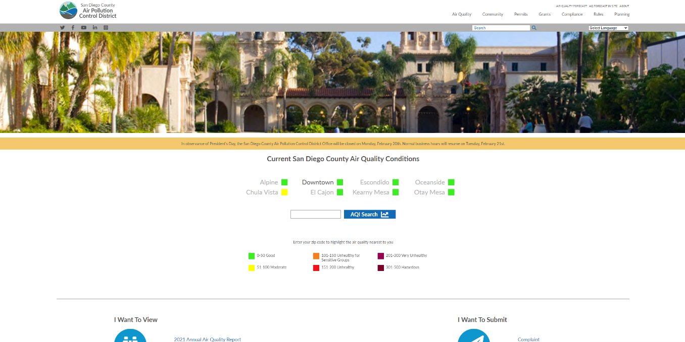

Figure 2 San Diego County Air Pollution Control District website homepage. The Air Quality link is marked with a red box.

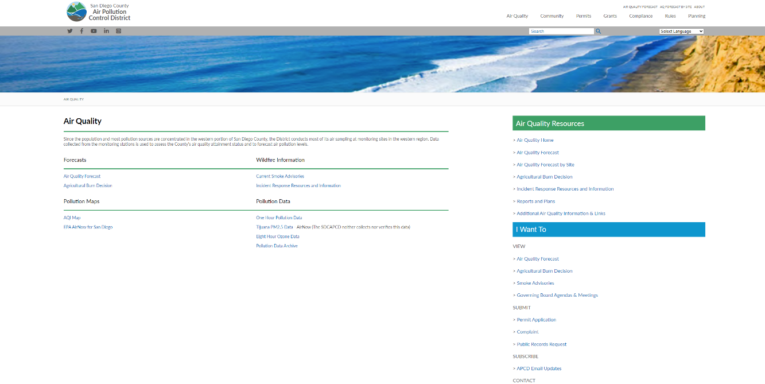

Figure 3 San Diego Air Pollution Control District Air Quality page. AQI Forecast is marked by a blue box, and historical data archive is marked by a green box.

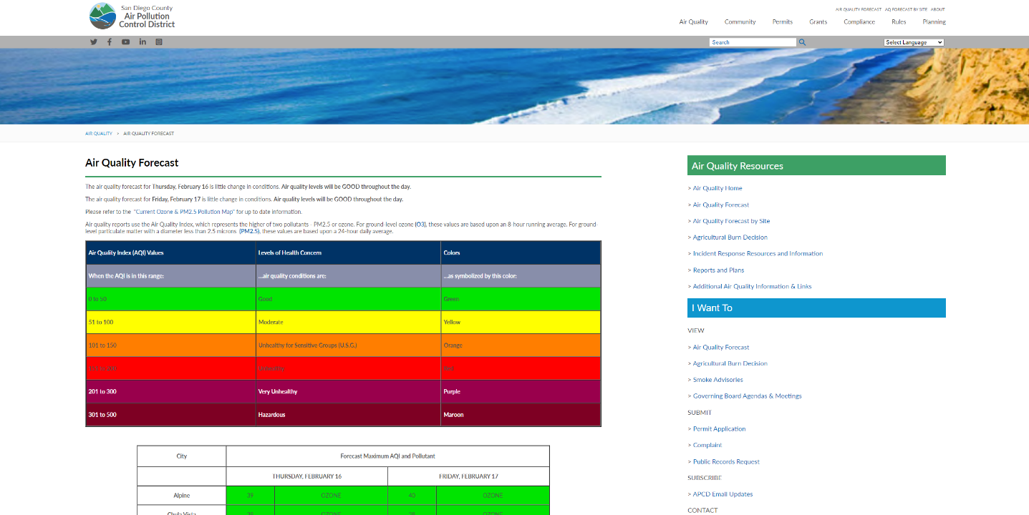

Figure 4 San Diego County Air Pollution Control District Air Quality Forecast page

## California Air Resources Board – AQview

The California Air Resources Board maintains a database of air quality data across California called [AQview](http://aqview.arb.ca.gov/home), which is shown in Figure 5. Clicking on the Access Data dropdown menu, marked by a red box, brings up two options: [Continuous Monitoring](http://aqview.arb.ca.gov/continuous-monitoring-data) (Figure 6) and [Additional Monitoring & Reports](http://aqview.arb.ca.gov/additional-monitoring-data) (Figure 7).

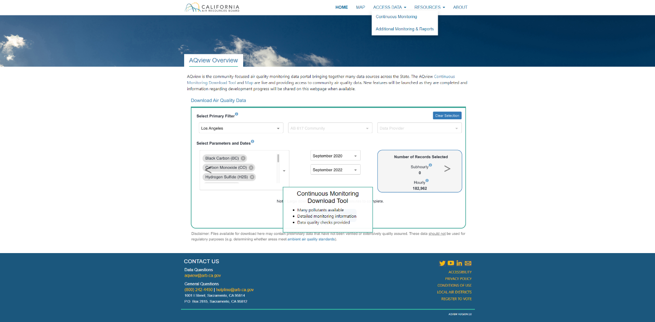

Figure 5 California Air Resources Board AQview homepage

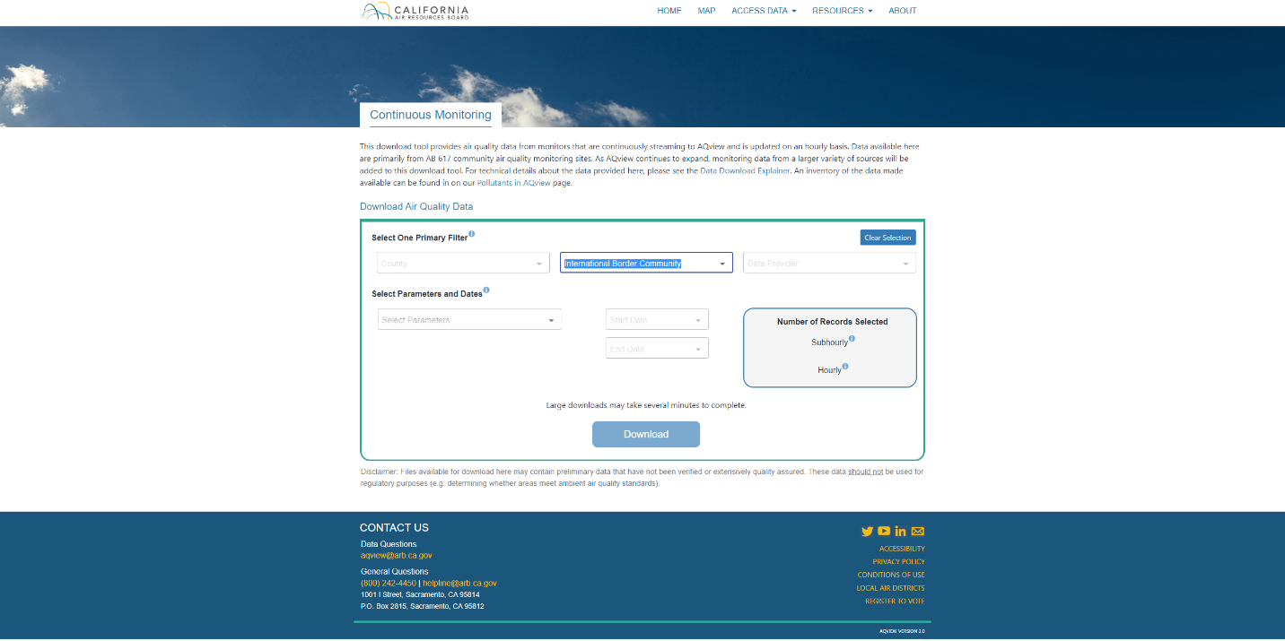

Figure 6 California Air Resources Board AQview Continuous Monitoring data page

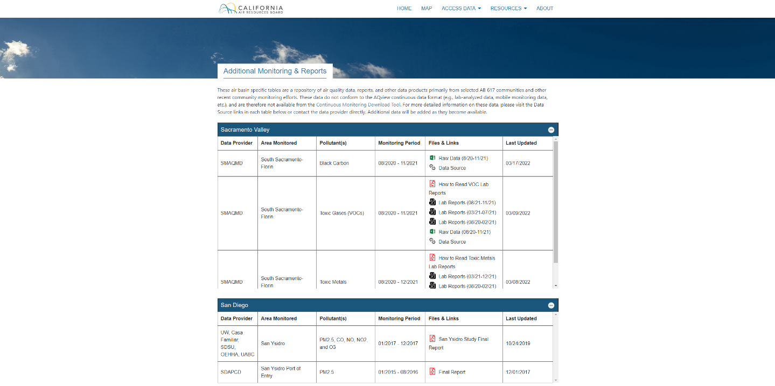

Figure 7 California Air Resources Board AQview Additional Monitoring & Reports

## United States Environmental Protection Agency Air Quality System

Per the [United States Environmental Protection Agency Air Quality System website](http://www.epa.gov/aqs): “The Air Quality System (AQS) contains ambient air pollution data collected by EPA, state, local, and tribal air pollution control agencies from over thousands of monitors. AQS also contains meteorological data, descriptive information about each monitoring station (including its geographic location and its operator), and data quality assurance/quality control information.” The homepage is shown in Figure 8 and includes support, documentation, and other helpful links.

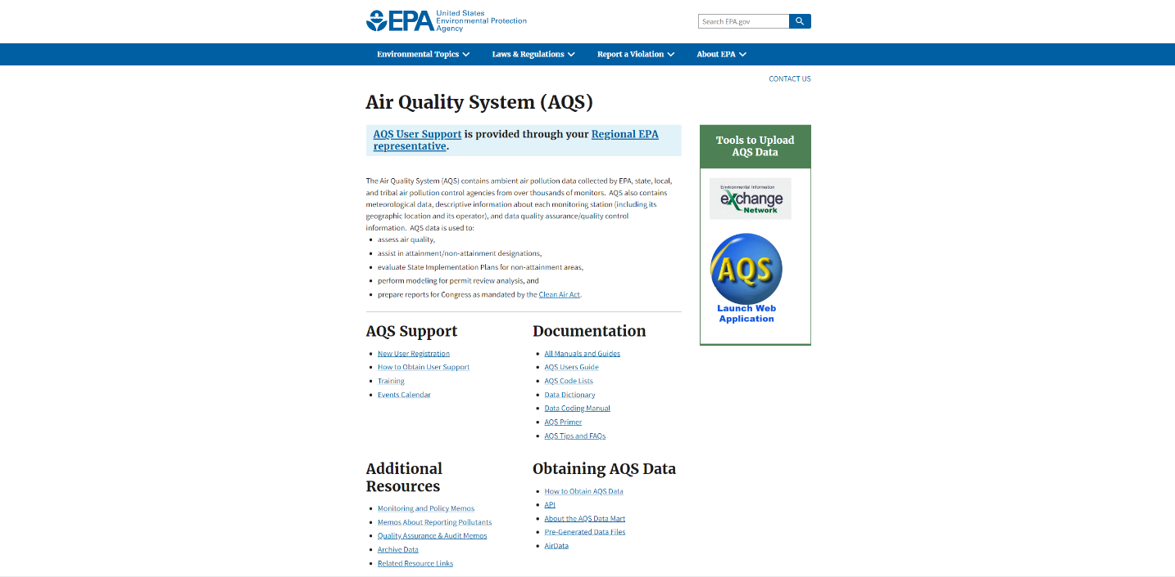

Figure 8 United States Environmental Protection Agency Air Quality System homepage